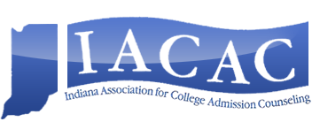
IACAC National Conference Grant
Available for Public High School IACAC members only. Grant award provides funding to be used toward registration fees, and hotel, airline and/or meal costs that will be reimbursed after the conclusion of the conference. Application deadline is June 30; award will be made by July 6. Recipient must register for NACAC National Conference by July 16 (register yourself for conference). Recipient will be expected to provide a short report of conference experience in writing to IACAC Executive Board that could be used in IACAC promotional materials as well as receipts for all expenses incurred.

_____________________________________________________________________________________
Name (please print or type)

_____________________________________________________________________________________
Title

_____________________________________________________________________________________
High School and Years in Position

School Address

City, State, Zip

Work Phone and Personal Phone

Work Email and Summer Email (if different)

Principal and Supervisor Name and Contact Information

If you are awarded the funds, have you received permission from your School/Principal to attend? Yes No

Are you currently a member of NACAC? Yes No

Interest in attending NACAC and Receiving Grant (300 words or less), please attach

NACAC takes place September 27-29, in Salt Lake City, Utah at the Salt Palace Convention Center www.nacacconference.org

Questions: Contact Jean Howell at iacacexecassistant@gmail.com

